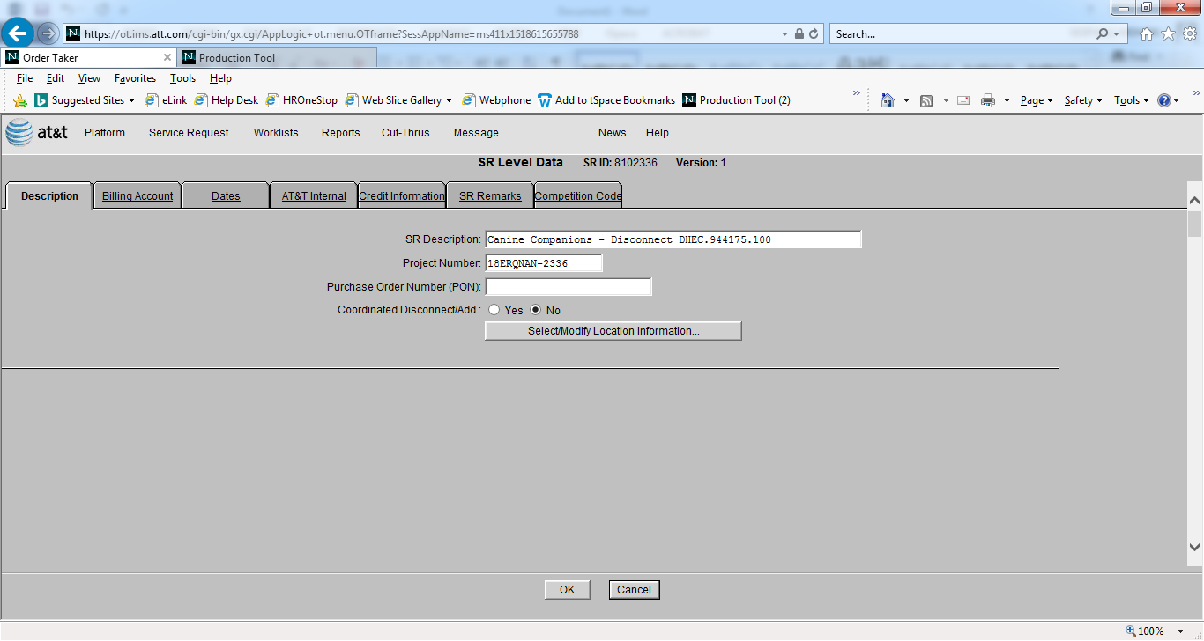

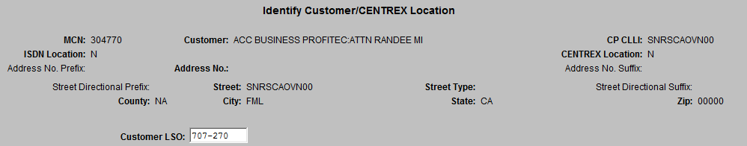

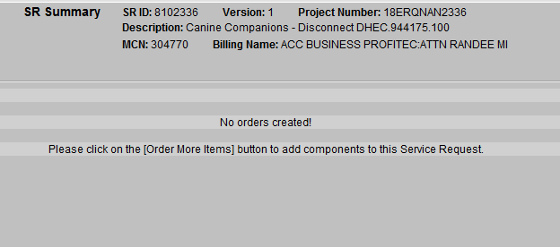

SQL> @getmcnclli

Please enter SRID: 8102336

SRID SERVICEREQUESTID CUSTOMERPRE I MCN I S CUSTOMERLOCATIONID ADDRESS CUSTOMERID

--------------- ---------------- ----------- - --------- - - ------------------ ---------- ----------

8102336 1531549 SNRSCAOVN00 N 304770 F Y 2739651 2468303 1421108

SQL> @getorders

Please enter SRID: 8102336

no rows selected

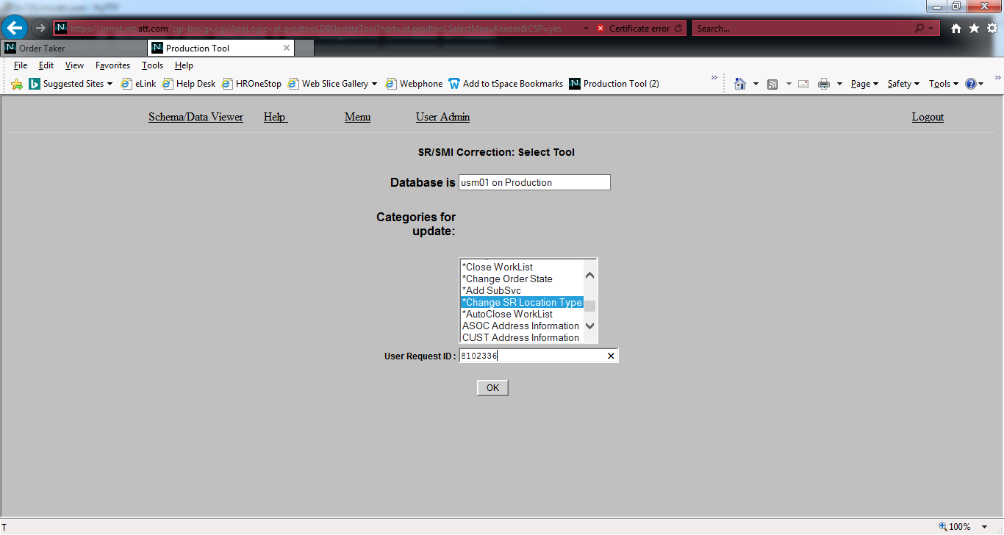

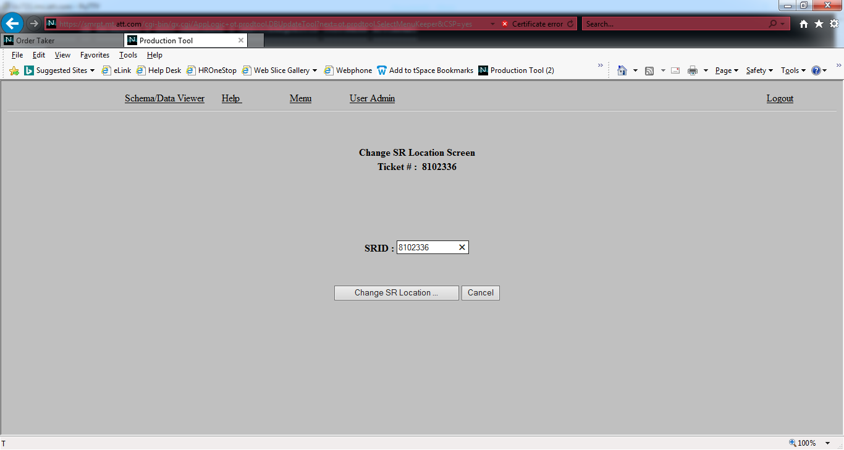

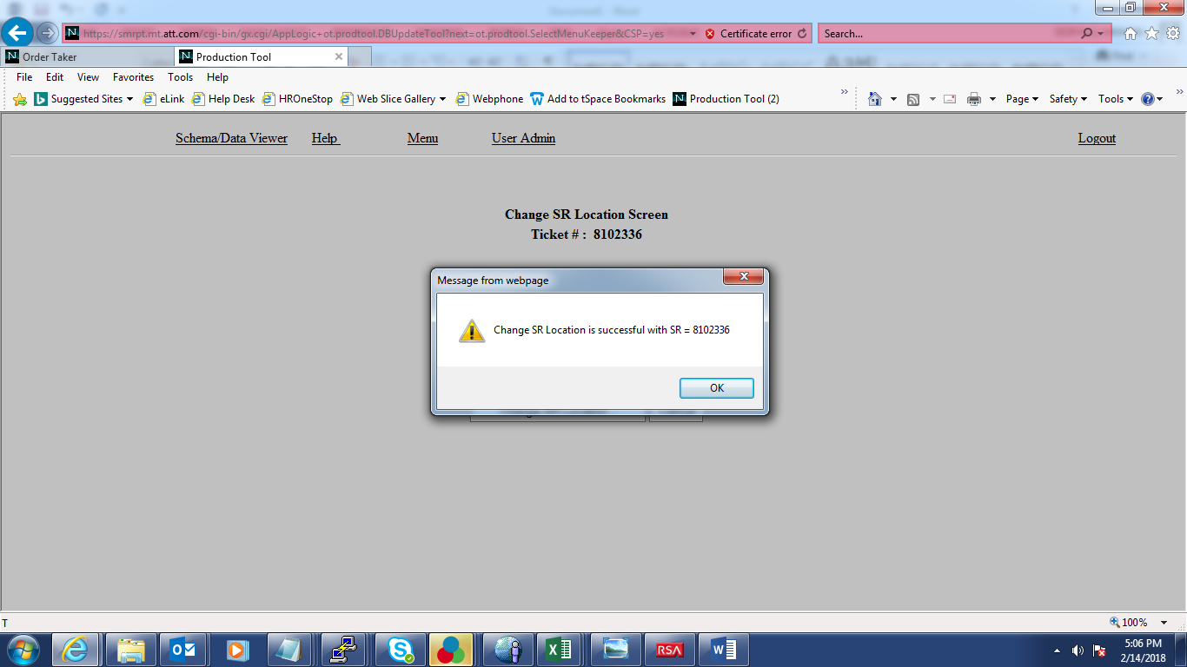

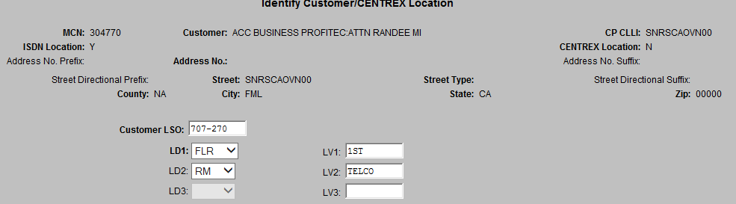

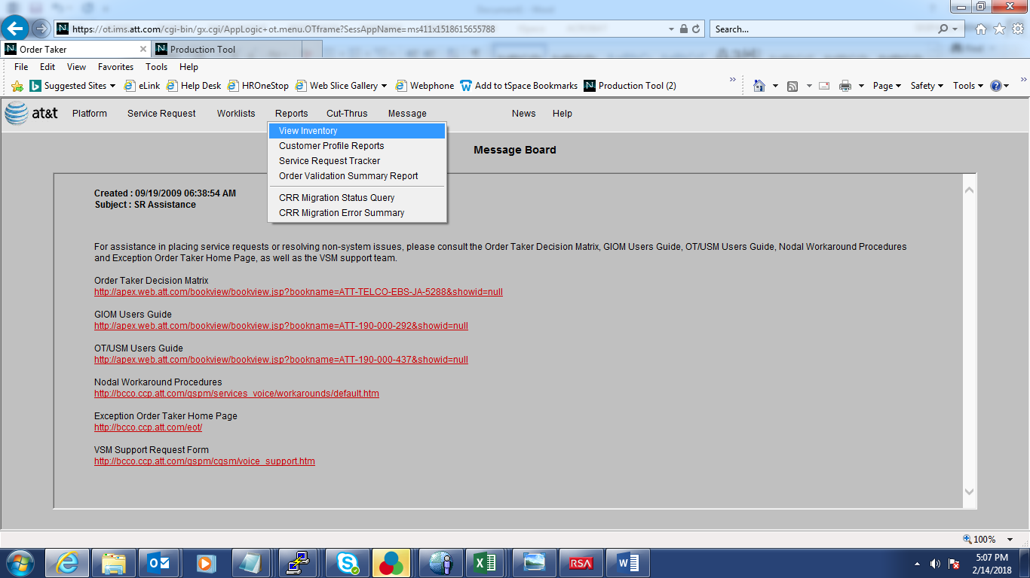

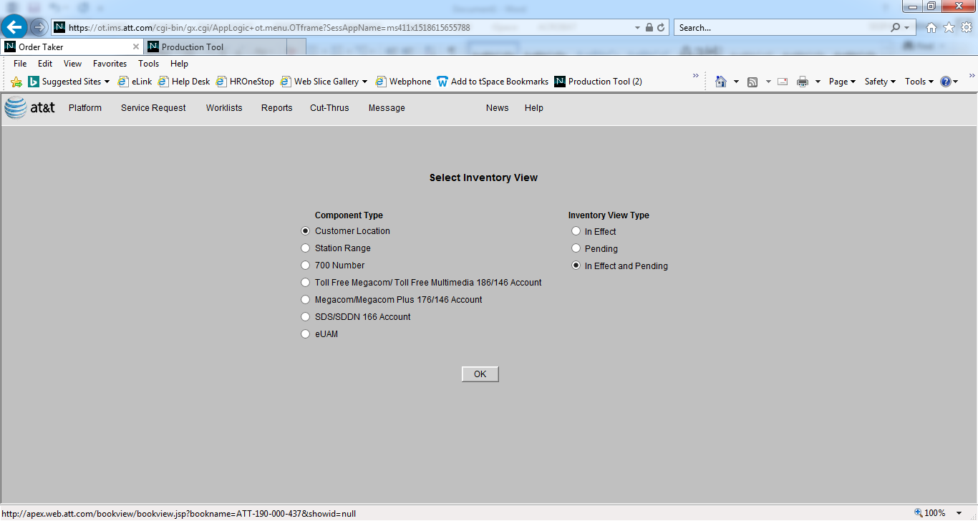

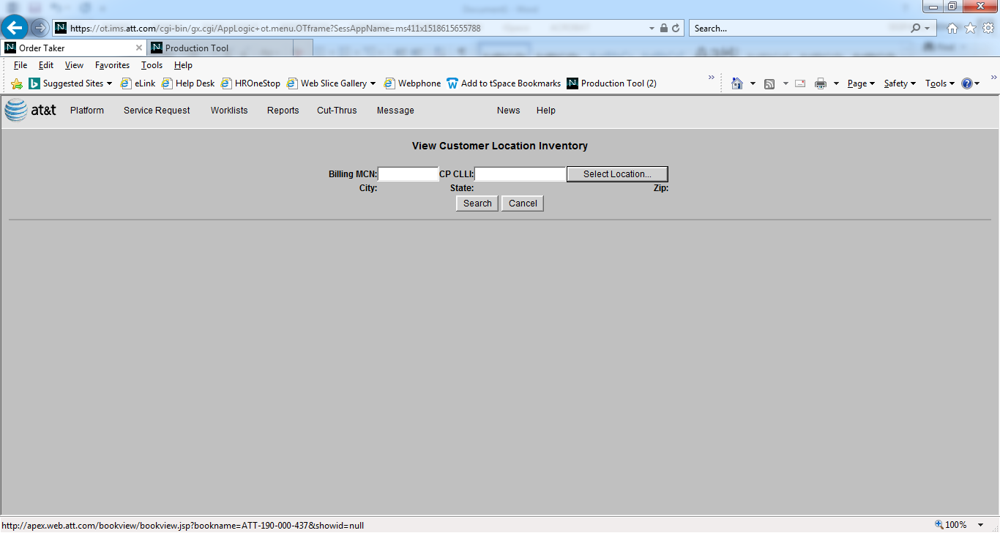

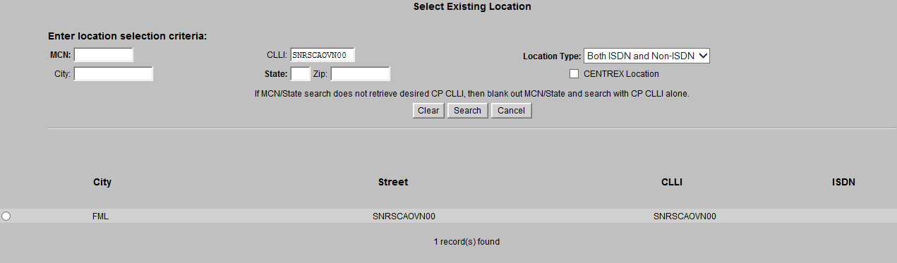

SQL> select count(1) from (select s.srid,s.state,cl.CUSTOMERPREMCLLI,cl.ISDNINDICATOR,cl.INVENTORYFLAG

FROM u_servicerequest s,u_customer c,u_customerlocation cl WHERE s.servicerequestid=c.SERVICEREQUESTID AND c.CUSTOMERID=cl.CUSTOMERID

AND cl.CUSTOMERPREMCLLI like 'SNRSCAOVN00' and cl.ISDNINDICATOR='Y'); 2 3

COUNT(1)

----------

1

SQL> select count(1) from (select s.srid,s.state,cl.CUSTOMERPREMCLLI,cl.ISDNINDICATOR,cl.INVENTORYFLAG

FROM u_servicerequest s,u_customer c,u_customerlocation cl WHERE s.servicerequestid=c.SERVICEREQUESTID AND c.CUSTOMERID=cl.CUSTOMERID

AND cl.CUSTOMERPREMCLLI like 'SNRSCAOVN00' and cl.ISDNINDICATOR='N'); 2 3

COUNT(1)

----------

0

SQL> select clli,liCUSTOMERLOCATIONID, ISDNindicator from u_licustomerlocation where clli like 'SNRSCAOVN00';

CLLI LICUSTOMERLOCATIONID I

----------- -------------------- -

SNRSCAOVN00 2059976 N

SQL> update u_licustomerlocation set ISDNindicator='Y' where liCUSTOMERLOCATIONID=2059976;

1 row updated.

SQL> select clli,liCUSTOMERLOCATIONID, ISDNindicator from u_licustomerlocation where clli like 'SNRSCAOVN00';

CLLI LICUSTOMERLOCATIONID I

----------- -------------------- -

SNRSCAOVN00 2059976 Y

SQL> commit;

Commit complete.

